SIMATS ENGINEERING ASSESSMENT TOOL 2

COURSE NAME: COMPUTER NETWORKS COURSE CODE: CSA0706

COURSE OUTCOME COVERED

CO4:

Design network topologies star, mesh, bus, and hybrid using networking devices, transmission media, and cabling standards
(BL2,BL6)
Assessment Tool Weightage: 30%

Annexure A
Industry Problem Solving Task

Code of Conduct:
I RUCHITA.S(192572081) certify that this submission is my original work and that I have adhered to the guidelines specified for this assessment.
I understand that any violation of academic integrity rules will result in disciplinary action.

Signature of the student:

RUCHITA.S
Annexure A
Industry Problem Solving Task

- A star topology is ideal for a 20-person startup because all devices connect to a central switch, making the network easy to manage and troubleshoot. At the core sits a Layer 2/Layer 3 managed switch (such as a Cisco Catalyst or Netgear ProSafe) with at least 24 ports to accommodate all workstations, printers, and VoIP phones with room to grow. Each device connects to the switch using Cat6 UTP cables, which support Gigabit speeds up to 100 meters — more than sufficient for any typical office floor plan. The switch uplinks to a router/firewall (such as a Cisco RV series or pfSense appliance) that handles internet access, DHCP, and network address translation. A Wi-Fi access point connected to the switch extends wireless coverage for laptops and mobile devices. The key advantage of this design is fault isolation: if one workstation's cable fails, only that single node goes offline, leaving all other 19 employees unaffected. Centralised cable management also simplifies future moves, adds, and changes.

SOLUTION:

A star topology is suitable for a 20-person startup because every device is connected to a central switch. This makes the network easy to manage, expand, and troubleshoot.

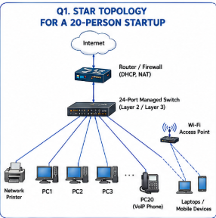

Required Components
Component | Purpose
24-port managed switch | Central connection point
Router/Firewall | Internet access, DHCP and NAT
Cat6 UTP cable | Connects devices to switch
Wi-Fi Access Point | Wireless connectivity
PCs/Printers/VoIP phones | End-user devices
The PDF specifies Cat6 UTP, a 24-port switch, router/firewall, and Wi-Fi access point for this design.

Advantages
Feature | Benefit
Easy management | All devices are centrally connected
Fault isolation | Failure of one cable affects only one device
Scalability | More devices can be added easily
Troubleshooting | Faults can be identified at the switch
Performance | Dedicated connection between each device and switch
Example: If the cable connecting PC5 fails, only PC5 loses connectivity; the other employees continue working.

Conclusion
Therefore, star topology is an efficient, manageable, and scalable solution for a 20-person startup.
- A bank demands near-zero downtime, making a full or partial mesh topology the right choice. In a full mesh, every core network device — routers, core switches, and servers — connects directly to every other device, so no single link or node failure can bring down the network. For a bank, a partial mesh is typically deployed at the core layer (connecting all core switches and firewalls to each other) while the distribution and access layers use redundant uplinks to at least two core switches. Dual enterprise-grade routers (such as Cisco ASR or Juniper MX series) provide BGP-based redundant internet connectivity. All links between core devices use fiber optic cables — either single-mode for long distances between buildings or multi-mode OM4 within the data center — because fiber is immune to electromagnetic interference, supports very high bandwidth, and is essential for maintaining low-latency financial transactions. Redundant power supplies, UPS systems, and RAID storage arrays further complement the mesh design. The justification is straightforward: when a link fails in a mesh, traffic automatically reroutes through alternative paths in milliseconds using protocols like OSPF or BGP, satisfying regulatory requirements for uptime and data integrity.

SOLUTION:

A bank requires near-zero downtime, so a full or partial mesh topology is appropriate. Multiple paths are provided between important network devices, allowing traffic to use an alternative path when a link fails.
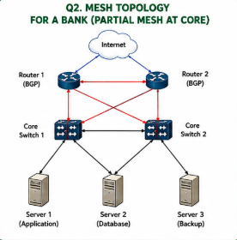

Network Design

Component | Purpose
Core switches | High-speed central connectivity
Enterprise routers | Redundant Internet connectivity
Firewalls | Network security
Fiber optic cables | High-speed and reliable connections
Servers | Banking applications/data
UPS | Backup power
RAID | Data protection
OSPF/BGP | Routing and automatic path selection
The source specifically describes partial mesh at the core, redundant uplinks, dual routers, fiber links, UPS, RAID, and OSPF/BGP.

Full Mesh vs Partial Mesh
Full Mesh | Partial Mesh
Every core device connects to every other device | Only critical devices have multiple connections
Very high redundancy | High redundancy
More expensive | More cost-effective
More cabling required | Less cabling
Suitable for extremely critical links | Practical for enterprise/banking networks

Why Fiber Optic?
Core Device ===== Fiber ===== Core Device
High Bandwidth
Low Latency
EMI Resistant
Fiber is used because it provides high bandwidth, low latency, and immunity to electromagnetic interference.

Failure Handling
Normal:
A -------- B
\ /
\ /
C

If A ---- B fails:

A B
\ /
\ /
C
|
Traffic reroutes through C
Protocols such as OSPF or BGP can route traffic through alternative paths when a link fails.

Conclusion
A partial/full mesh provides the redundancy and reliability required by banking networks, making it suitable where downtime must be minimized.
- For a small classroom lab with a tight budget, bus topology offers the lowest hardware cost because all computers share a single common communication line — the bus — eliminating the need for a central switch or hub. A single coaxial cable (RG-58, 50-ohm) or, in a modern variation, a single Cat5e/Cat6 cable daisy-chained through an inexpensive unmanaged hub runs along the length of the room. Each computer connects to the backbone using a T-connector and a BNC connector in a classic coaxial setup, with terminators (50-ohm) placed at both ends of the cable to absorb signals and prevent reflection. For a more contemporary low-cost implementation, a single inexpensive 8- or 16-port unmanaged switch replaces the terminators and uses Cat5e UTP patch cables to each workstation — achieving bus-like simplicity at minimal cost. The primary limitation is that the network is susceptible to collisions and a single cable break disrupts all connected machines, but for a supervised classroom environment with light usage (internet browsing, file sharing), this trade-off is entirely acceptable. No dedicated server is required; a teacher's PC can share resources using built-in Windows/Linux file sharing.

SOLUTION:

For a small classroom with a tight budget, the source identifies bus topology as a low-cost option because devices share a common communication line.
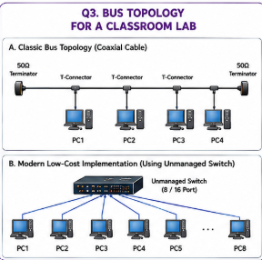

Components
Component | Purpose
RG-58 coaxial cable | Main bus/backbone
T-connectors | Connect computers to backbone
BNC connectors | Cable connections
50-ohm terminators | Prevent signal reflection
Computers | End devices
The PDF specifies RG-58 50-ohm coaxial cable, T-connectors, BNC connectors, and terminators for the classic bus setup.

Advantages and Disadvantages
Advantages | Disadvantages
Low hardware cost | Cable failure can affect all devices
Simple design | Collisions can occur
Less equipment required | Difficult troubleshooting
Suitable for light traffic | Limited scalability

Modern Low-Cost Variation
Unmanaged Switch
+-------------+
| |
+---+---+---+---+-+---+
| | | | | |
PC1 PC2 PC3 PC4 PC5 PC6
The source also mentions a modern low-cost implementation using an inexpensive unmanaged switch and Cat5e UTP patch cables.

Conclusion
Bus topology can be considered for a small, low-traffic classroom environment where cost is the main concern, although its failure and collision limitations must be accepted

- A large university campus serves thousands of users across multiple buildings — lecture halls, labs, libraries, dormitories, and administration — making a single topology inadequate. A hybrid topology combines the best elements of multiple designs: a fiber-based ring or mesh at the campus backbone level for redundancy, a star topology within each building for manageability, and bus or tree structures within individual labs for cost-efficiency. At the campus core, high-speed fiber optic cables (single-mode, 10 Gbps or 40 Gbps) interconnect core routers and multilayer switches using a ring or partial mesh arrangement, ensuring that no single link failure isolates an entire building. Each building has its own distribution switch connected to the campus core via dual fiber uplinks. Within each building, a traditional star topology branches from the distribution switch to floor-level access switches, which then connect individual devices via Cat6 cables. This hierarchical three-layer model — core, distribution, and access — is the industry standard for enterprise and campus networks because adding a new building simply means installing a new distribution switch and running fiber to the core, with no disruption to existing infrastructure. Wireless access points throughout the campus connect via PoE (Power over Ethernet) to access switches, eliminating the need for separate power cabling. The hybrid design thus delivers redundancy at the backbone, simplicity at the building level, and scalability campus-wide.

SOLUTION:

A university campus has thousands of users distributed across multiple buildings. Therefore, a single topology is not sufficient. A hybrid topology combines different topologies at different network levels.
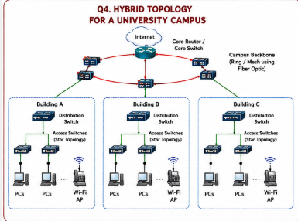

Topology Used at Each Level
Network Level | Topology | Purpose
Campus backbone | Ring/Mesh | Redundancy
Building | Star | Easy management
Individual labs | Bus/Tree | Cost efficiency
Wireless | Access Point | Mobile connectivity
The source specifically proposes fiber ring/mesh at the campus backbone, star within buildings, and bus/tree structures within labs.
Three-Layer Architecture
CORE LAYER
High-Speed Backbone
|
+----------+----------+
| |
DISTRIBUTION DISTRIBUTION
LAYER A LAYER B
| |
+----+----+ +----+----+
| | | | | |
ACCESS ACCESS ACCESS ACCESS ACCESS ACCESS
| | | | | |
PCs PCs APs PCs PCs APs

Technologies
Technology | Application
Single-mode fiber | Long-distance campus connections
Multimode OM4 | Data-center connections
Cat6 | Device connections
PoE | Powers wireless access points
Layer 3 switches | Routing between network segments
The source describes 10/40 Gbps fiber, dual fiber uplinks, Cat6, PoE, and the three-layer core/distribution/access architecture.

Major Advantages
- High scalability
- Backbone redundancy
- Easy building expansion
- Simple management inside buildings
- Reduced impact of individual link failures

Conclusion
Hybrid topology is the best choice for a university because it combines redundancy, manageability, cost efficiency, and scalability
- Designing a network for a company with multiple departments involves creating a structured and scalable architecture using switches and routers to ensure efficient communication and security. Each department (such as HR, Finance, Sales, and IT) is connected through dedicated Layer 2 switches that form the access layer, allowing devices like computers and printers to communicate within the same department. These switches are then connected to a central Layer 3 switch or router, which acts as the core layer and enables communication between different departments through inter-VLAN routing. Virtual LANs (VLANs) are configured to logically separate each department’s network, improving security and reducing broadcast traffic. A router is also used to connect the internal network to external networks such as the internet, often with firewall functionality for security. Redundant links and backup paths can be included to ensure reliability, while proper IP addressing and subnetting are applied for efficient network management. This hierarchical design improves performance, enhances security, and allows easy expansion as the company grows.

SOLUTION:

For a company with departments such as HR, Finance, Sales, and IT, a hierarchical network using switches, routers, VLANs, and inter-VLAN routing provides efficient communication and security.
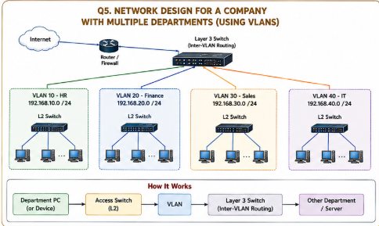

VLAN Allocation
Department | Example VLAN | Purpose
HR | VLAN 10 | HR systems
Finance | VLAN 20 | Financial systems
Sales | VLAN 30 | Sales systems
IT | VLAN 40 | IT administration

How It Works
Department PC
|
v
Layer 2 Access Switch
|
v
VLAN
|
v
Layer 3 Switch
|
| Inter-VLAN Routing
v
Other Department / Server
VLANs logically separate departments, while the Layer 3 switch or router performs inter-VLAN routing when communication between departments is required.

Security and Performance
Feature | Benefit
VLAN | Separates departments
Inter-VLAN routing | Allows controlled communication
Firewall | Protects internal network
Subnetting | Efficient IP address management
Redundant links | Improves reliability
Layer 3 switch | Fast internal routing

Example IP Addressing
Department | Network
HR | 192.168.10.0/24
Finance | 192.168.20.0/24
Sales | 192.168.30.0/24
IT | 192.168.40.0/24
These IP networks are an example implementation; the source only requires proper IP addressing and subnetting.

Conclusion
The hierarchical VLAN-based design provides security, efficient communication, better performance, easy management, and future scalability.

RUBRICS FOR CALCULATION

Criteria | Weightage | Exemplary (4) | Proficient (3) | Developing (2) | Beginning (1)
Problem Analysis | 15% | Clearly identifies and deeply  analyzes the industry problem with all factors | Good understanding with minor gaps | Basic understanding;  some key aspects missing | Poor or incorrect understanding of the problem
Solution Design | 20% | Innovative, practical, and industry-relevant solution | Effective solution with minor  limitations | Partially suitable solution | Inappropriate or unclear solution
Technical Implementation | 20% | Fully functional, accurate, and well-executed implementation | Mostly functional with minor errors | Partially implemented solution | Incomplete or non-functional implementation
Use of Tools & Technologies | 10% | Appropriate and advanced use of relevant tools and technologies | Correct use of tools | Limited or basic use of tools | Incorrect or no use of tools
Problem-Solving Approach | 10% | Logical, systematic, and well-structured approach | Mostly logical approach | Somewhat disorganized approach | No clear approach
Innovation & Creativity | 10% | Highly creative and original solution | Some creativity | Limited originality | No creativity
Testing & Validation | 5% | Thorough testing with real-world  scenarios | Adequate testing | Minimal testing | No testing
Documentation & Presentation | 5% | Clear, professional, and well-documented | Good documentation | Basic documentation | Poor or no documentation
Teamwork / Collaboration | 5% | Excellent coordination and contribution (if team-based) | Good collaboration | Limited participation | No collaboration or contribution

